Name____________________________________________ Date ________________Blk:______ NB#_____
What is Wind Energy?
Wind is a form of solar energy. Winds are caused by the uneven heating of the atmosphere by the sun, the irregularities of the earth's surface, and rotation of the earth. Wind flow patterns are modified by the earth's terrain, bodies of water, and vegetation. Humans use this wind flow, or motion energy, for many purposes: sailing, flying a kite, and even generating electricity. The term "wind energy" describes the process by which the wind is used to generate mechanical energy or electricity. Wind turbines convert the kinetic energy in the wind into mechanical energy. Mechanical energy can be used for specific tasks (such as grinding grain or pumping water) or a generator can convert this mechanical energy into electricity.
1. What are the three contributing factors that cause wind?
__________________________________________________________________________________
2. Where are the best locations for wind energy to be supplied?
__________________________________________________________________________________
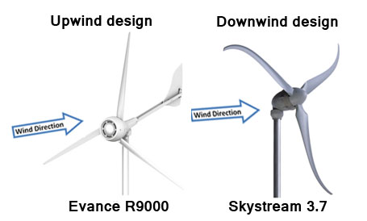
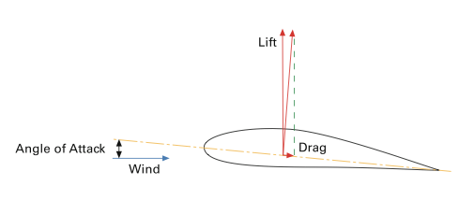
How Do Wind Turbines Work?
A wind turbine works the opposite of a fan. Instead of using electricity to make wind, like a fan, wind turbines use wind to make electricity. The wind turns the blades, which spin a shaft, which connects to a generator and makes electricity. Wind turbines, like windmills, are usually mounted on a tower to capture the most energy. Wind turbines operate on a simple principle. The energy in the wind turns two or three propeller-like blades around a rotor. The rotor is connected to the main shaft, which spins a generator to create electricity. Wind turbines are mounted on a tower to capture the most energy. At 100 feet (30 meters) or more above ground, they can take advantage of faster and less turbulent wind. A blade acts much like an airplane wing. When the wind blows, a pocket of low-pressure air forms on the downwind side of the blade.
3. What is the relationship between a fan used to cool you in the summer & a windmill used to generate electricity? __________________________________________________________________________________
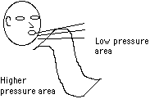
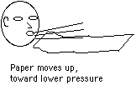
The low-pressure air pocket then pulls the blade toward it, causing the rotor to turn. This is called lift. The force of the lift is actually much stronger than the wind's force against the front side of the blade, which is called drag. The combination of lift and drag causes the rotor to spin like a propeller, and the turning shaft spins a generator to make electricity. Wind turbines can be used to produce electricity for a single home or building, or they can be connected to an electricity grid for more widespread electricity distribution.
4. Discuss the role of lift and drag to allow the blade to move.
__________________________________________________________________________________________________
Wind speed, the height of the blades and the number of blades contribute to the amount of energy generated. The shape of the blades can also effect the windmill’s ability to generate power. Please be sure to research other designs on the computer. Below sketch two unique blade designs.
- Sketch One | Sketch Two
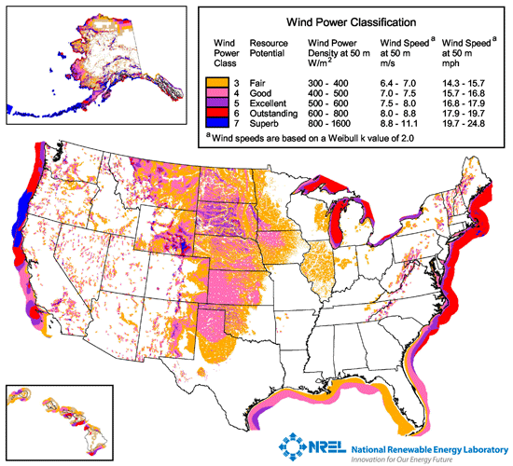
Locating the Best Places for Windmill
Not all locations are suitable for wind energy development. They need to be evaluated to determine if the cost associated with installing a wind turbine will likely be balanced by the value of energy generated over time.
One of the first steps to developing a wind energy project is to assess the area's wind resources and estimate the available energy. To help the wind industry identify the area best suited for development, the U.S. Wind Energy Program works with the National Renewable Energy Laboratory (NREL) and other organizations to measure, characterize, and map wind resources 50 meters (m) to 100 m above ground. At the local level, towns and contractors will work with homeowners to determine the cost and likely financial benefits of wind turbine installation. Often the first step is to temporarily install an anemometer to test the wind at a farm or home over several months or even a year.
6. Why can you not just set up a windmill anywhere?
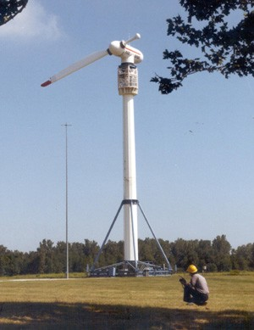
_________________________________________________________________________________________________________
How Many Blades?
Most wind turbines use either two or three blades. Research indicates that as more blades are added there is an increase in aerodynamic efficiency, but this efficiency decreases dramatically with each added blade. For example, increasing the number of blades from one to two can yield a six percent increase in aerodynamic efficiency, but increasing the blade count from two to three yields only an extra three percent in efficiency. And, of course, there are cost implications too. Each additional blade in a design will increase the cost of the end product, so engineers have to factor in both the increased efficiency and the increased cost of manufacturing to determine a design that will be the best for an application. Aesthetics is also a consideration. A small, two or three blade design might be best for a residential area, where a homeowner just wants to pull from the wind enough energy to power their own home, and would prefer a quieter option. A giant 12 blade design would not look very nice atop their home and would perhaps generate more energy than they need, and likely more noise too! To the right you can see how NASA tested a one-bladed rotor configuration. (Photo by NASA Glenn Research Center)
7. What two factors are considered when engineers decide how many blades should be used in their design? __________________________________________________________________________________

Wind Turbine Lab
Coffee Stirrers | .75/each |  | Rubber Band | .45/each
Toothpicks | .65/each |  | Aluminum Foil | 2.25/sq inch
Index Card | 1.00/each |  | Tape | .75/inch
Bendable Wire | 2.00/inch |  | Pipe Cleaner | .85/inch
String | 1.00/inch |  | Paper | 1.50/sq inch
Paperclips | .90/each |  | Plastic Wrap | 1.75/sq inch
Glue | 2.00 |  | Coffee Filter | 2.50/each
Dixie Cup | 3.00/each |  | Mounting Base | 5.00/each
**********Waste materials is still part of cost – what you take you pay for***********
8. Drawing of Design | Materials Needed & Budget: | Quantity | Item Cost | Total Cost
Directions: Evaluate your results & complete the evaluation worksheet.
9. Did you succeed in creating a windmill that could generate electricity? If so, what was the highest voltage achieved? If not, why did it fail?

10. Did you decide to revise your original design or request additional materials while in the construction phase? If you had to do it all over again, how would your planned design change? Why?

12. Why would engineers adapt their original plans during the construction of systems or products?

13. How did the most "efficient" design (the one with the lowest cost and highest voltage) differ from your own?

14. What drawbacks does a wind turbine have as a reliable source of energy? What technologies exist that might compensate for these drawbacks?

15. What advantages does the windmill have as a renewable source of energy?
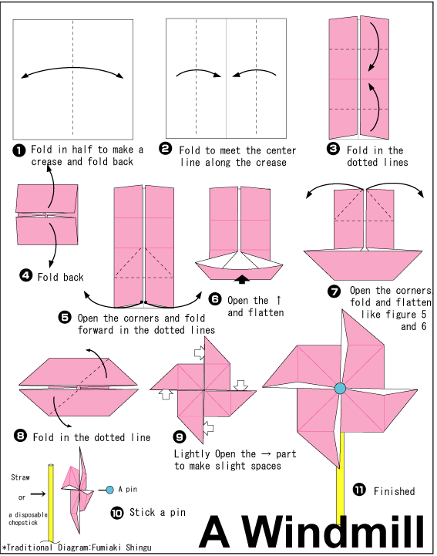
Student Origami Windmill Pattern – One Option for Students

