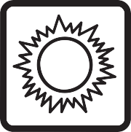Solar Name ___________________________ Blk ____ Date____________ NB#___

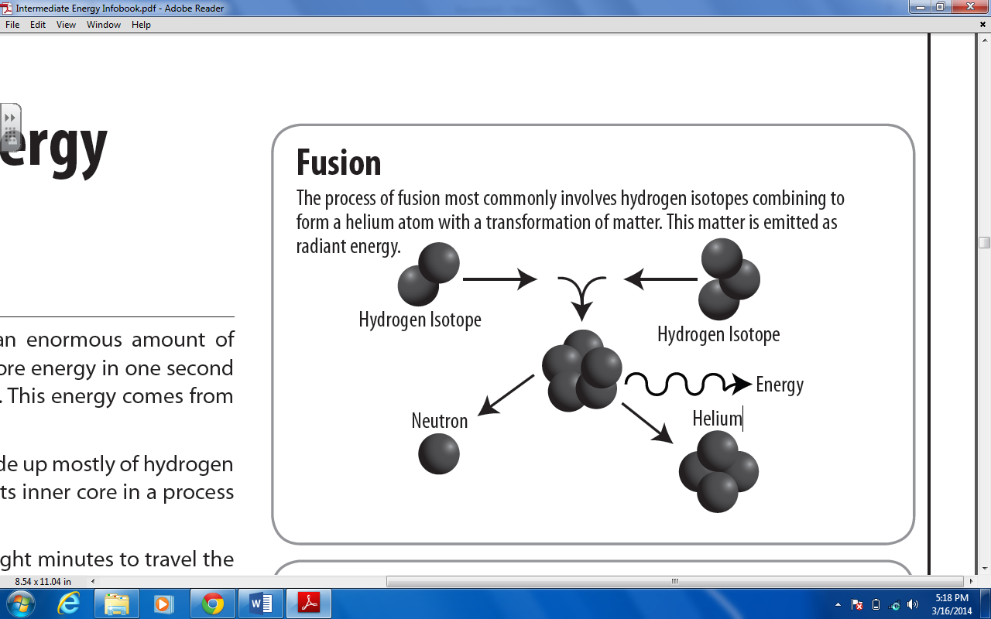***What Is Solar Energy?***

Every day, the sun radiates (sends out) an enormous amount of energy—called solar energy. Every hour enough solar energy reaches the Earth to supply our nation’s energy needs for a year! Solar energy is considered a renewable energy source due to this fact. This energy comes from within the sun itself. Like most stars, the sun is a big gas ball made up mostly of hydrogen and helium gas. The sun makes energy in its inner core in a process called nuclear fusion. It takes the sun’s energy just a little over eight minutes to travel the 93 million miles to Earth. Solar energy travels at the speed of light, or 186,000 miles per second.

**1. The sun has two primary elements creating its mass. What are they?**

**Solar Collector**

On a sunny day, a closed car becomes a solar collector. Light energy passes through the window glass, is absorbed by the car’s interior, and converted into heat energy. The heat energy becomes trapped inside.

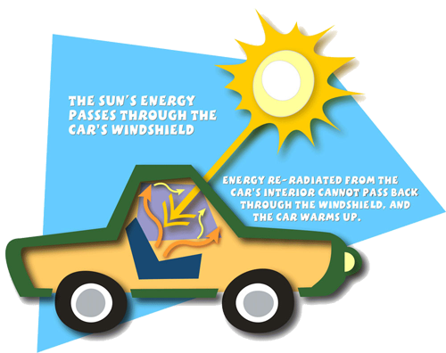

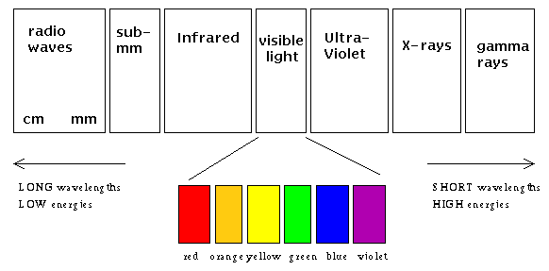**___________________________________________**

Only a small part of the radiant energy (see below) that the sun emits into space ever reaches the Earth, but that is more than enough to supply all our energy needs. Today, people use solar energy to generate electricity and heat buildings and water.

***Solar Collectors***

Heating with solar energy is not as easy as you might think. Capturing sunlight and putting it to work is difficult because the solar energy that reaches the Earth is spread out over a large area. The sun does not deliver that much energy to any one place at any one time. The amount of solar energy an area receives depends on the time of day, the season of the year, the cloudiness of the sky, and how close you are to the Earth’s Equator. A solar collector is one way to capture sunlight and change it into usable heat energy. A closed car on a sunny day is like a solar collector.

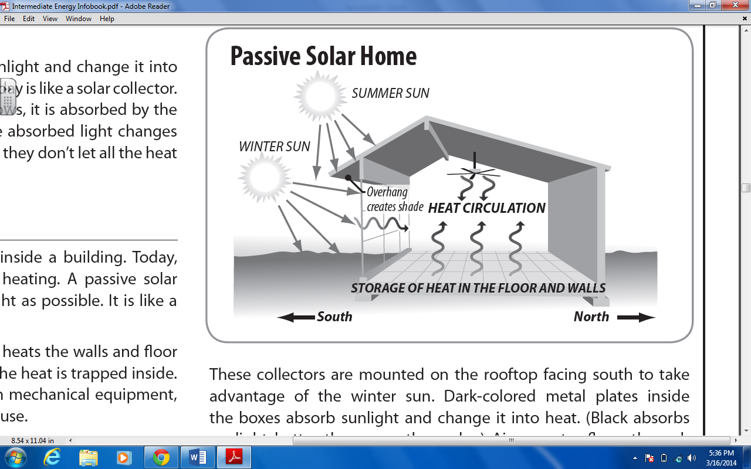

**2. Name two factors that impact “how much” solar energy a location gets:**

_________________________________________________________

_________________________________________________________

***Solar Space Heating***

Solar space heating means heating the space inside a building. Today, many homes use solar energy for space heating. A passive solar home is designed to allow the maximum amount of sunlight in the home as possible. It is like a big solar collector. Sunlight passes through the windows and heats the walls and floor inside the house. The light can get in, but the heat is trapped inside. A passive solar home does not depend on mechanical equipment, such as pumps and blowers, to heat the house. An active solar home, on the other hand, uses special equipment to collect sunlight. An active solar house may use special collectors that look like boxes covered with glass. These collectors are mounted on the rooftop facing south to take advantage of the winter sun. Dark-colored metal plates inside the boxes absorb sunlight and change it into heat. (Black absorbs sunlight better than any other color.) Air or water flows through the collectors and is warmed by the heat. The warm air or water is distributed to the house, just as it would be with an ordinary furnace system.

1. 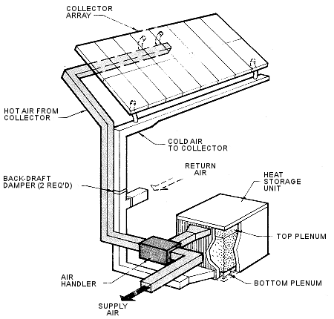**Discuss the difference between a passive solar home and an active solar home:**

___________________________________________________________________

___________________________________________________________________

***Solar Water Heating***

Solar energy can be used to heat water. Heating water for bathing, dishwashing, and clothes washing is the second largest home energy cost. Installing a solar water heater can reduce your water heating bill 50 percent. A solar water heater works a lot like solar space heating. In our hemisphere, a solar collector is mounted on the south side of a roof where it can capture sunlight. The sunlight heats water in a tank. The hot water is piped to faucets throughout a house, just as it would be with an ordinary water heater.

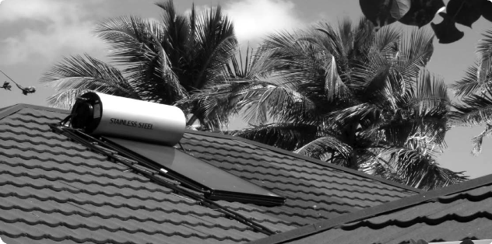

**4. What is an advantage of using solar water heating over traditional electric heating? _______________________________________________**

*Solar Electricity*

Solar energy can be used to produce electricity. Two ways to make electricity from solar energy are using photovoltaic cells and solar thermal systems:

|  |  |
| --- | --- |
| ***Photovoltaic Electricity***  Photovoltaic comes from the words photo, meaning light, and volt, a measurement of electricity. Sometimes photovoltaic cells are called PV cells or solar cells for short. You are probably familiar with photovoltaic cells. Solar-powered toys, calculators, and roadside telephone call boxes all use solar cells to convert sunlight into electricity. Solar cells are made up of silicon, the same substance that makes up sand. Silicon is the second most common substance on Earth. Solar cells can supply energy to anything that is powered by batteries or electrical power.  Electricity is produced when radiant energy from the sun strikes the solar cell, causing the electrons to move around. The action of the electrons starts an electric current. The conversion of sunlight into electricity takes place silently and instantly. There are no mechanical parts to wear out.  You won’t see many photovoltaic power plants today. Compared to other ways of making electricity, photovoltaic systems are expensive. | ***Solar Thermal Electricity (CSP)***  Like solar cells, solar thermal systems, also called concentrated solar power (CSP), use solar energy to produce electricity, but in a different way. Concentrated Solar Power (CSP) systems use very different technology than photovoltaic systems. CSP systems use the sun as the "thermal heat" source as opposed to the photon energy of the sun as PV systems do. CSP systems are marketed mainly to utilities as they take up a fair amount of land and require mechanical maintenance.  **5. Compare and contrast Photovoltaic Cells and CSP**    **CSP**  **PV** |

Name ________________________________________________ Blk _______ Date _________________NB# ___________

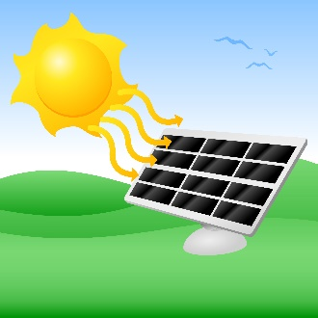

***Solar Lab***

*To learn how different amounts of light changes how solar cells work. To learn that different types of work require different amounts of energy. To predict how much electricity can be generated from light.*

**PART 1: PREDICTING VOLTAGE**

1. Plug in the 60W lamp and make sure it is off.

2. Connect the Solar Cell to the Voltmeter. The red lead from the Solar Cell is connected to the red lead of the Voltmeter with the red cord. The black lead from the Solar Cell is connected to the COM lead of the Voltmeter with the black cord.

3. Turn the dial on the Voltmeter to 20V setting.

4. Place the lamp over the Solar Cell at a distance that you decide upon. Measure the distance with a ruler.

5. Turn on the lamp. BE VERY CAREFUL, THE LAMP AND BULB GET VERY HOT.

6. Record the voltage in the data table.

7. Repeat the steps with the 100W lamp, maintain the same distance.

8. Predict the voltage you would get with a 75W lamp.

**PART 2: DIFFERENT WORK; DIFFERENT ENERGY**

1. Plug in either the 60W lamp or the 100W lamp.

2. Connect the Solar Cell to the Solar Energy Kit. Match up colors; red to red and black to black.

3. Place the lamp over the Solar Cell at the same distance you have decided to use for Part 1.

4. Turn on the lamp. BE VERY CAREFUL, THE LAMP AND BULB GET VERY HOT.

5. Switch between the SOUND, the MOTOR, and the BULB on the Solar Energy Kit.

6. Record observations about the intensity of the work being performed.

7. Repeat the steps above using the same lamp but with 2 other distances between the lamp and Solar Unit. (Make one distance closer and the second distance further from the lamp)

*TABLE FOR PART 1:*

|  |  |  |  |
| --- | --- | --- | --- |
| Distance from Solar Cell (cm) | VOLTAGE W/ 60W BULB | PREDICTED VOLTAGE W/ 75W BULB | VOLTAGE W/ 100W BULB |
|  |  |  |  |

**6. Would you numbers change if you moved the lamp closer or further away? Explain.**

***_______________________________________________________________________________________________________***

***7. Place a number in front of the listed solar conversion processes in order:***

|  |  |  |  |  |  |
| --- | --- | --- | --- | --- | --- |
|  | ***Electric Energy is created*** |  | ***Light energy impacts the solar cell*** |  | ***Electrons are excited and begin to move*** |

***8.* Why does the voltmeter record a voltage when the lamp is turned off?**

***_______________________________________________________________________________________________________***

*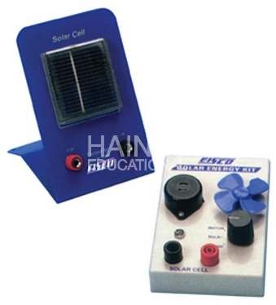TABLE FOR PART 2:*

|  |  |  |  |
| --- | --- | --- | --- |
| **Distance from Solar Cell** | **SOUND Observations** | **FAN Observations** | **LIGHT Observations** |
|  |  |  |  |
|  |  |  |  |
|  |  |  |  |

**9. Which output, sound, fan, light had the most response from the farthest distance? Explain.**

***_______________________________________________________________________________________________________***

***10. What would need to be done to make a solar electric system work for a home?***

***_______________________________________________________________________________________________________***

***_______________________________________________________________________________________________________***

***_______________________________________________________________________________________________________***

