Name ________________________________________________Blk ___ Date_______________ NB#_____
Petroleum
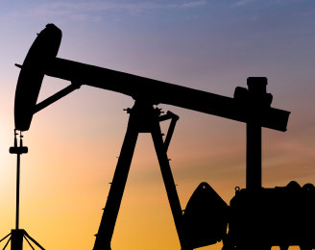
Oil and natural gas together make petroleum. Petroleum (which is Latin for “rock oil”) is a fossil fuel, meaning it was made naturally from decaying prehistoric plant and animal remains. It is a mixture of hundreds of different hydrocarbons molecules containing hydrogen and carbon that exist sometimes as a liquid (crude oil) and sometimes as a vapor (natural gas).

1. What does Petroleum mean in Latin?
________________________________________________________________

How is Petroleum Formed?
Oil and natural gas were formed from the remains of prehistoric plants and animals—that’s why they’re called “fossil fuels!” Hundreds of millions of years ago, prehistoric plant and animal remains settled into the seas along with sand, silt and rocks. As the rocks and silt settled, layer upon layer piled up in rivers, along coastlines and on the sea bottom trapping the organic material. Without air, the organic layers could not rot away. Over time, increasing pressure and temperature changed the mud, sand and silt into rock (known as source rock) and slowly “cooked” the organic matter into petroleum. Petroleum is held inside the rock formation, similar to how a sponge holds water.
2. Where is petroleum found? __________________________________________________________________________________
Countries with Largest Known Oil Reserves
Saudi Arabia | Iran | Kuwait | Venezuela | Libya
Canada | Iraq | United Arab Emirates | Russia | Nigeria
Global hot spots that may house significant new oil and gas reservoirs include:
Offshore western Africa | Offshore Brazil | Gulf of Mexico | Areas across Asia & Pacific | Russia & Alaska

Over millions of years, the oil and gas that formed in the source rock deep within the Earth moved upward through tiny, connected pore spaces in the rocks. Some seeped out at the Earth’s surface, but most of the petroleum hydrocarbons were trapped by nonporous rocks or other barriers. These underground traps of oil and gas are called reservoirs. Reservoirs are not underground “lakes” of oil; they are made up of porous and permeable rocks that can hold significant amounts of oil and gas within their pore spaces. This is somewhat like a sponge holding water. Some reservoirs are hundreds of feet below the surface, while others are thousands of feet underground.
3. What are oil reserves? __________________________________________________________________________________

4. Describe what a nonporous rock is: __________________________________________________________________________________
Are We Running Out of Oil and Gas?
No one can know for certain how much oil and gas remains to be discovered. But geologists sometimes make educated guesses. The total amount of oil or gas in a reservoir is called original oil. For a specific reservoir, engineers estimate this amount using information about the size of the reservoir trap and properties of the rock. Some of the original oil and gas deposited millions of years ago has been discovered, while some remains undiscovered—the target of future exploration. Discovered (or known) resources can be divided into proved reserves and prospective or unproved (probable and possible) resources.
5. What lab have we done in the past, which might demonstrate one way scientist may go about discovering oil reservoirs? __________________________________________________________________________________
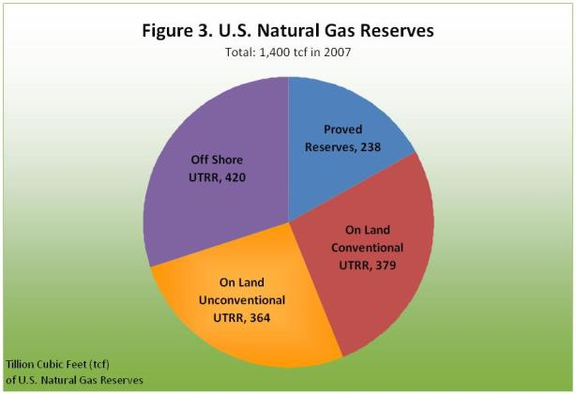
Proved reserves are the quantities of oil or gas from known reservoirs that are expected to be recoverable with current technology and at current economic conditions. Prospective resources are those that may be recoverable in the future with advanced technologies or under different economic conditions.
6. Can we access prospective reserves at this time? Why/Why not?
______________________________________________
The Oil & Gas Journal (OGJ) estimates that at the beginning of 2009, worldwide reserves were 1.34 trillion barrels of oil and 6,254 trillion cubic feet (Tcf) of natural gas. The oil estimate is 16 billion barrels of oil higher than in 2007, reflecting additional discoveries, improving technology and changing economics. The United States consumed a total of 6.87 billion barrels (18.83 million barrels per day) in 2011 and 7.0 billion barrels (19.18 million barrels per day) of refined petroleum products and biofuels in 2010. For both years, this was about 22% of total world petroleum consumption.
7. How much of the world supply does the USA consume annually? ______________________

Continental North America and much of continental Europe have already been explored heavily, and any new discoveries are likely to be small. But many areas of the globe are largely unexplored, and large new deposits are waiting to be found. These are just a few of the current areas of growth. Most observers agree that significant deposits of oil and gas remain undiscovered in the Middle East. The largest reserves of natural gas are found in Russia, Iran, Qatar, Saudi Arabia, the United Arab Emirates, the United States, Algeria, Nigeria, Venezuela and Iraq. At current consumption levels, the remaining reserves represent 44.6 years of oil and 66.2 years of natural gas. Does this mean that the world will be out of fossil fuels in 50 years or so? That theory has been around since the 1970s. In fact, the figures for years of remaining reserves have remained relatively constant during the past few decades as the industry has balanced consumption with newly discovered oil and gas deposits.
8. Where do we expect to find yet undiscovered oil in the future? ______________________

9. How old will you be when the oil reserves run out? _______ and natural gas? _________
Uses for Petroleum
Where would we be without petroleum? You can kiss lipstick goodbye!
Not only does petroleum provides fuel to run our vehicles, cook our food, heat our homes and generate electricity, it is also used in plastics, medicines, food items, and countless other products, from aspirin to umbrellas, and yes—lipstick! Transportation needs use 66% of all available petroleum to fuel cars, buses, trucks and jets. That means 34% of oil is used for all the other items that make our daily lives easier. Most people have no idea how often they come in contact with things made from oil or natural gas.
10. What percentage of oil is used for non-transportation purposes?
__________________________________________________________________________________

Meeting Higher Demands for Petroleum
In areas of the world that are still developing, businesses and individuals are demanding greater mobility for themselves and their products. World vehicle ownership is projected to increase from 122 vehicles per thousand people in 1999 to 144 vehicles per thousand in 2020, with the largest growth occurring in emerging nations. The total consumption of liquid fuels worldwide is expected to increase by 25% from 2006 to 2030.

Here are some of the many items made from petroleum
Artificial Hearts | Credit Cards | Hair Dryers | Patio Screens | Tents
Aspirin | Deodorant | Hang Gliders | Perfumes | Toothpaste
Balloons | Digital Clocks | House Paint | Photographic Film | Toys
Bandages | Dyes | Ink | Photographs | Umbrellas
Blenders | Fertilizers | Insecticides | Piano Keys
CD Players | Food Preservatives | Life Jackets | Roller Blades
Clothing | Footballs | Lipstick | Roofing
Compact Discs/DVDs | Furniture | Luggage | Shampoo
Computers | Garbage Bags | Medical Equipment | Shaving Cream
Containers | Glasses | Medicines | Soft Contact Lenses
Crayons | Glue | MP3 Players | Surfboards
Credit Cards | Golf Balls | Pantyhose | Telephones

11. Circle four things you MUST have in your life.
World population is currently around 6 billion people but is expected to grow to approximately 7.6 billion by 2020. That will mean a huge increase in the demand for transportation fuels, electricity and many other consumer products made from oil and natural gas.
12. What is going to impact the demand on future oil needs? __________________________
Oil Spill Cleanup Lab
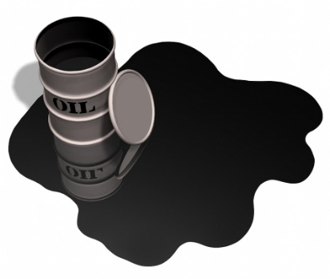
Set up a small scale oil spill and demonstrate the difficulties faced by those given the task of cleaning up the real thing. Cleanup attempts will be made using a variety of common materials. A brief examination of the effects of spilled oil on marine and aquatic life will also be performed.
Background
The number-one largest spill in history occurred in the Gulf of Mexico from April 20th to July 15th 2010. An estimated 200 million gallons of oil were released into the Gulf of Mexico during this time. The magnitude and circumstances of the spill, the devastation of human and aquatic life lost, the amount of coastline affected (over 1,000 miles of beaches and wetlands), and the after effects on the environment and economic damages two years later, continue to be addressed. Much of the attention is now focused on the methods used to clean up oil from the ocean, affected beaches, and wetlands.
Briefly, some of the methods used to clean up oil spills are: (1) dispersants, chemicals that break down the oil into small droplets that are more easily degraded; (2) booms, floating “sausages” with skirts that hang a few feet below the surface and corral and contain the oil to facilitate mechanical removal; (3) skimmers, towed or self-propelled machines that collect the oil by skimming or vacuuming it from the surface, (4) hand scrubbing, blotting, or rinsing (with high pressure hoses) the oil from cobble or pebble beaches, and (5) enhanced biodegradation. Biodegradation is a naturally-occurring process in which microorganisms effectively “digest” the spilled oil. Enhanced biodegradation (also called bioremediation) involves the application of nitrogen- and phosphorus-containing fertilizers to accelerate these natural processes.
Wildlife affected by the spilled oil continues to be a magnet for a great deal of media attention, and mortality estimates vary widely. There is no question that everything from planktonic organisms to fish, seabirds, whales, and dolphins were adversely affected. Data from numerous research projects are still being analyzed and lingering effects of this event will be felt for some time.

INSTRUCTIONS:
1. Pour about 200 mL of water into your aluminum pan. This represents the ocean.
2. 1 teaspoon of oil (motor or vegetable) will be added to simulate an oil spill occurring in the ocean.
3. Begin your timer for 15 minutes. This represents how much time you will have to clean up the spill.
4. Gently blow on the ocean to represent wind and waves. Rock the pan a bit (gently) to also represent wave action.
5. Using the materials allowed, try to clean up the spill as efficiently as possible. Record the amount of time you use each piece of equipment in the data table.
6. Add a small quantity of detergent solution to the spill and note the effects. Retest selected materials with the detergent added.
EQUIPMENT | COST | MINUTES/QUANTITY | TOTAL COST
Pipette (skimmer) | $100/minute
Cotton ball | $20/each
Q-Tip | $50/each
Plastic Cup  (Waste container) | $500/each
Rubber Band  (Boom for “fencing” oil) | $750/each
Labor | $1000/person/minute
TOTALS:

Discussion Questions
13. What did the most effective materials have in common? What did the least effective materials have in common?

14. How would these methods translate into a larger, more realistic scale?

15. Discuss what effects weather might have. Note: high winds and waves will inhibit cleanup efforts but may actually improve the actions of dispersants (analogous to the detergent tested) and hasten natural physical degradation.

16. Birds rely on air trapped in their layers of feathers to keep warm and buoyant. What effect does oil have on the feathers? What will happen to the bird under these circumstances?

