Name_____________________________________ Date _________ Blk____ NB# ________
What Is Natural Gas?

Natural gas is a fossil fuel like petroleum and coal. Natural gas is called a fossil fuel because it was formed from the remains of ancient sea plants and animals. When the plants and tiny sea animals died hundreds of millions of years ago, they sank to the bottom of the oceans where they were buried by sediment and sand. This eventually turned into sedimentary rock. The layers of plant and animal matter and sedimentary rock continued to build until the pressure and heat from the Earth turned the remains into petroleum and natural gas.
1. Number the steps in order for the process for natural gas to form:
 | Slowly Turn in Sedimentary Rock |  | Pressure from the Earth is Applied |  | Natural Gas and Petroleum are formed |  | Biotic Forms Die |  | Dead Remains are Buried
Natural gas is trapped in underground rocks much like a sponge traps water in pockets. Natural gas is really a mixture of gases. The main ingredient is methane. Methane has no color, odor, or taste. As a safety measure, natural gas companies add an odorant, mercaptan (it smells like rotten eggs), to the gas so that leaking gas can be detected. People use natural gas mostly for heating. Natural gas should not be confused with gasoline, which is made from petroleum. Natural gas is almost always considered nonrenewable, which means we cannot make more in a short time. However, there are some renewable sources of methane, such as landfills and pig farms.
2. Why must natural gas companies add an odorant to the gas?
________________________________________________________________________________________

3. Where is the one place we can find a renewable source of natural gas?
__________________________________________________________________________________________
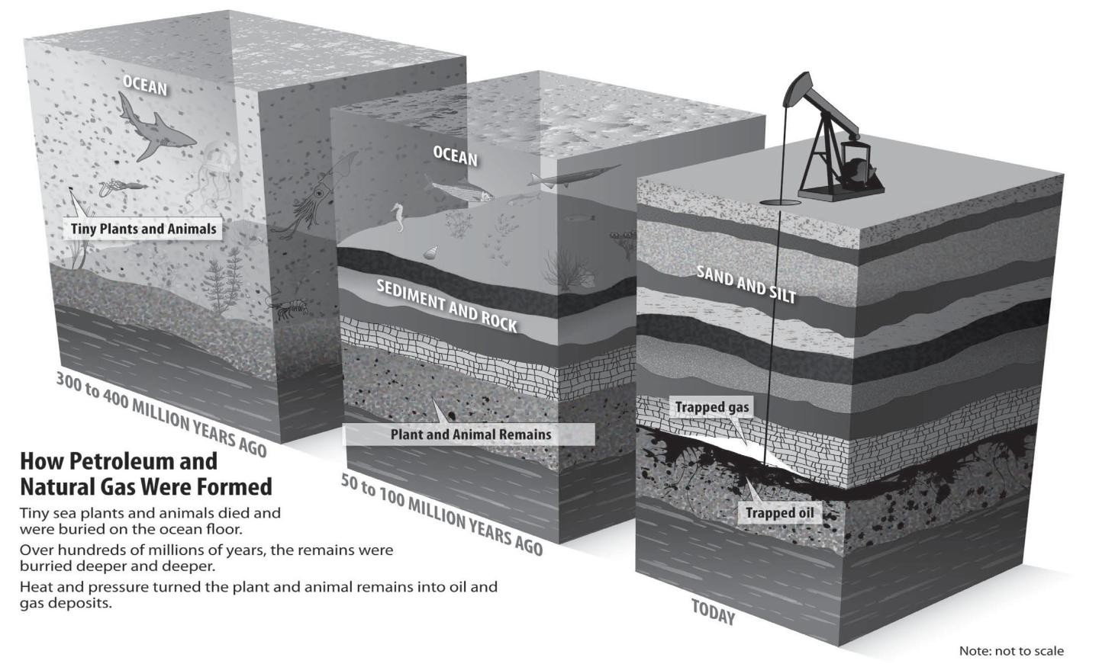History of Natural Gas
U.S. Natural Gas

ELECTRICITY 31.2%

RESIDENTIAL 19.4%
Data: Energy Information Administration
INDUSTRY
33.5% COMMERCIAL 13.0%
PIPELINE FUEL & TRANSPORTATION
2.9%

The ancient people of Greece, Persia, and India discovered natural gas many centuries ago. The people were mystified by the burning springs created when natural gas seeped from cracks in the ground and was ignited by lightning. They sometimes built temples around these eternal flames and worshipped the fire. About 2,500 years ago, the Chinese recognized that natural gas could be put to work. The Chinese piped the gas from shallow wells and burned it under large pans to evaporate sea water to make salt.

4. What is the first documented use of Natural Gas?
__________________________________________________________________________________________
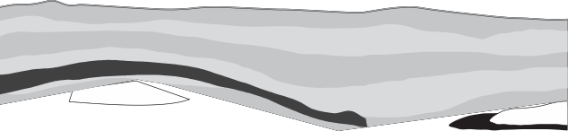In 1816, natural gas was first used in America to fuel street lamps in Baltimore, Maryland. Soon after, in 1821, William Hart dug the United States’ first successful natural gas well in Fredonia, New York. It was just 27 feet deep, quite shallow compared to today’s wells. Today, natural gas is the country’s second largest supplier of energy, after petroleum.
Locations of Natural
Gas
Coal Bed Methane
Convention al Non-
Sandst
O
Tight
Gas-rich
5. In what location was the first natural gas well dug and how deep was it?
__________________________________________
Natural gas can be hard to find since it is trapped in porous rocks deep underground. Scientists use many methods to find natural gas deposits. They may look at surface rocks to find clues about underground formations. They may set off small explosions or drop heavy weights on the surface to record the sound waves as they bounce back from the rock layers underground.
6. What are the three processes used for finding natural gas locations?
1. ___________________________ 2. ____________________________ 3. ____________________________
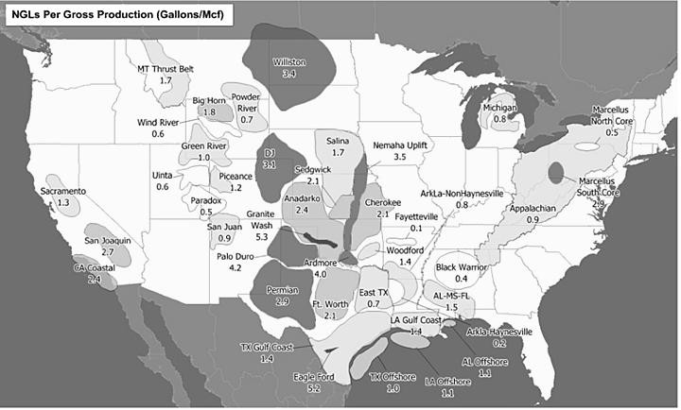Natural gas can be found in pockets by itself or in petroleum deposits. Natural gas wells average 8,600 feet (2.5 km) deep! After natural gas comes out of the ground, it is sent to a plant where it is cleaned of impurities and separated into its various parts. Natural gas is mostly methane, but it also contains small amounts of other gases such as propane and butane.

7. What are the three basic types for natural gases found?
1. ______________________________

2. ______________________________

3. ______________________________
Today natural gas is produced in 32 states, though just five states— Texas, Louisiana, Wyoming, Oklahoma, and Colorado—produce 65 percent of our supply. Natural gas is also produced offshore. About eight percent of natural gas production came from offshore wells in 2011. Scientists estimate that we have enough natural gas to last about 92 years at current prices and rate of consumption.

8. Which natural gas producing state is closest to North Carolina?
_____________________________________________________________________________
Natural gas can also come from other sources, such as the methane gas found in coal. Coal bed methane was once considered just a safety hazard to miners, but now it is a valuable source of energy. Another source of natural gas is the gas produced in landfills. Landfill gas, a biogas, is considered a renewable source of natural gas since it comes from something continually produced—trash.

9. Why would natural gas be a problem for coal miners? _____________________________________________________________________________

Shipping Natural Gas
Natural gas is usually shipped by pipeline. About two million miles of pipelines connect gas fields, to cities, to homes and businesses. Natural gas is sometimes transported thousands of miles in these pipelines to its final destination. It takes about five days to move natural gas from Texas to New York. Eventually, the gas reaches the city gate of a local gas utility. Smaller pipes carry the gas the last few miles to homes and businesses. A gas meter measures the volume of gas a consumer uses.

10. How long does it take natural gas to move along a pipeline from Texas to New York?

__________________________________________________________________________________________

Who Uses Natural Gas?
Just about everyone in the United States uses natural gas. Industry burns natural gas for heat to manufacture goods. Natural gas is also used as an ingredient in fertilizer, glue, paint, laundry detergent, and many other items. Residences, or homes, use natural gas for heating. Like residences, commercial buildings use natural gas mostly for heating.
Commercial users include stores, offices, schools, churches, and hospitals.

Natural gas can also be used to generate electricity. Many new power plants are using natural gas as fuel because it is cleaner burning and can produce electricity quickly when it is needed for periods of high demand. A small amount of natural gas is also used as fuel for automobiles. Natural gas is cleaner burning than gasoline, but to use it, vehicles must have special equipment.

11. What feature of Natural Gas makes it better to use then petroleum?
__________________________________________________________________________________________

Natural Gas and the Environment
Burning biomass or any fossil fuel, including natural gas, releases emissions into the air, including carbon dioxide, a greenhouse gas. Natural gas and propane are the cleanest burning fossil fuels. Compared to coal and petroleum, natural gas releases much less sulfur, carbon dioxide, and ash when it is burned. Scientists are looking for new sources of natural gas and new ways to use it.

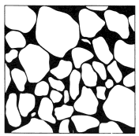Name_____________________________________ Date _________ Blk____ NB# ______
Natural Gas
Vocabulary: Porosity Gas Pipeline

To study the characteristics of different kinds of soil by measuring pore space.
What lab have we done in the past that looked at pore space? Give a brief outline of what we did:
____________________________________________________________
1. Add each soil sample the 30 ml line of the graduated cylinder.
3. Pour each sample into its own balloon. (Use funnel as needed)
4. Attach each balloon to a syringe.
5. GENTLY pull on plunger for Sample A (Sand).
6. Note the number of millimeters on the syringe
7. Record how far you could pull the syringe gently.
8. Repeat for Sample B (Clay).
9. WAIT!!! Guess how many milliliters you will get for the sand.
Enter Guess Here: _________________________________
10. Now confirm your guess.
__________________________________________________________
Samples | Volume of Rocks | Volume of Gas | Difference
Sample A  Gravel | 20 ml
Sample B  Clay | 20 ml
Sampler C  Sand | - l

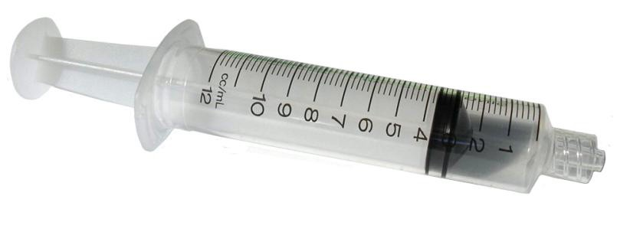

Concluding Questions:

1. What would one of the difficulties be in removing gas buried in the Earth?
____________________________________________________________________________________
2. What other types of soils could we have tested?
____________________________________________________________________________________

3. Which soil sample had the greatest porosity?
____________________________________________________________________________________
4. If methane is allowed to leak into the air before being used—from a leaky pipe, for instance—it absorbs the sun's heat, warming the atmosphere. For this reason, it's considered a greenhouse gas, like carbon dioxide. What does the term greenhouse gas mean?
__________________________________________

