Name ___________________________________ Date _______________ Blk _______ NB# _____
What Is Coal?

Coal is a fossil fuel formed from the remains of plants that lived and died hundreds of millions of years ago, when parts of the Earth were covered with huge swampy forests. Coal is called a nonrenewable energy source because it takes millions of years to form. The energy we get from coal today came from the energy that plants absorbed from the sun millions of years ago. All living plants store energy from the sun. After the plants die, this energy is usually released as the plants decay. Under certain conditions, however, the decay is interrupted, preventing the release of the stored solar energy. One hundred to four hundred million years ago, plants that fell to the bottom of the swamp began to decay as layers of dirt and water were piled on top. Heat and pressure from these layers caused a chemical change to occur, eventually creating coal over time.

1. Why do some dead plants become coal and others do not?
_________________________________________________________________________________

History of Coal in America
Native Americans used coal long before the first settlers arrived in the New World. Hopi Indians used coal to bake the pottery they made from clay. European settlers discovered coal in North America during the first half of the 1600’s. They used very little coal at first. Instead, they relied on water wheels and burning wood to power colonial industries. Coal became a powerhouse by the 1800’s. People used coal to manufacture goods and to power steamships and railroad engines. By the time of the American Civil War, people also used coal to smelt iron and steel. And by the end of the 1800’s, people began using coal to heat the water to power the turbines that generated electricity. Today, coal provides one-fifth (20.2 percent) of America’s energy needs. Almost 42 percent of our electricity comes from coal-fired power plants.

2. What property of coal makes it so relied upon as an energy source? _____________________

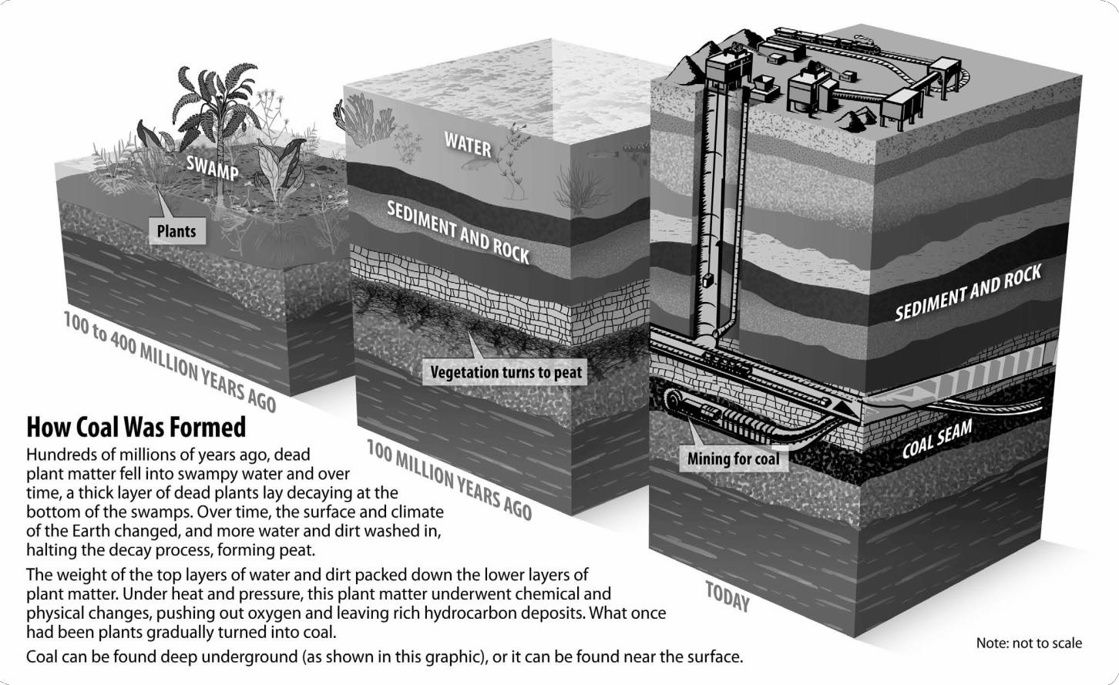

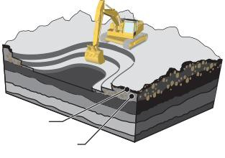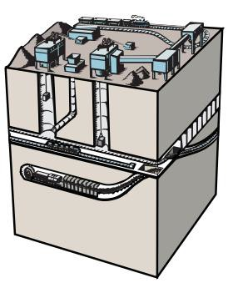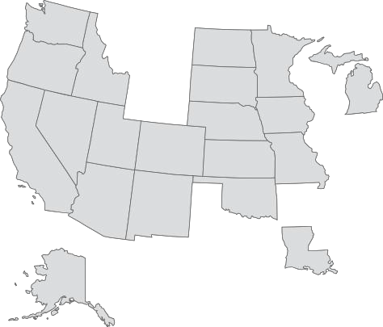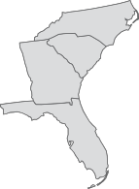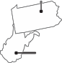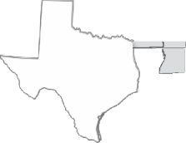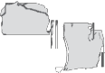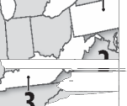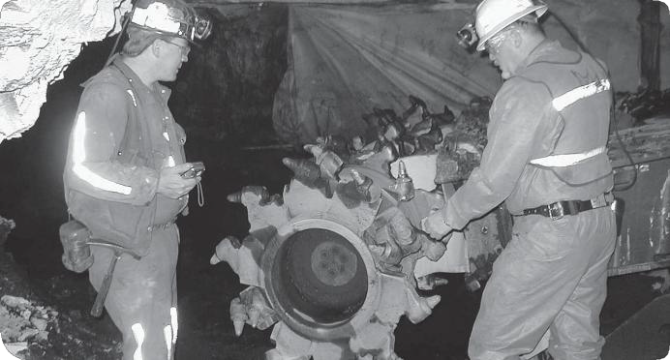Coal Mining
Surface
Deep
Topsoil
Overbur
Top Coal Producing
1
WYO
4
PENN
NI
5
TE
Data: Energy Information
U.S. Coal Consumption by Sector, 2011
ELECTRICIT Y 92. 6 %
INDUSTRY 7. 1 %
Data: Energy Information
Coal companies use two methods to mine coal: surface mining and underground mining. Surface mining is used to extract about two-thirds of the coal in the United States. Surface mining can be used when the coal is buried less than 200 feet underground. In surface mining, the topsoil and layers of rock are removed to expose large deposits of coal. The coal is then removed by huge machines. Once the mining is finished, the mined area is reclaimed. The dirt and rock are returned to the pit, the topsoil is replaced, and the area is seeded. The land can then be used for croplands, wildlife habitats, recreation, or offices and stores.
Underground (or deep) mining is used when the coal is buried deep within the Earth. Some underground mines are 1,000 feet deep! To remove coal from underground mines, miners are transported down mine shafts to run machines that dig out the coal.
3. Number the following as they occur with surface
mining:
 | Remove coal deposits with machines |  | Reclaim the area for other uses
 | Remove Surface Rocks and Topsoil |  | Mining of area is finished.

4. What is a reoccurring problem with underground mines (not in article – think about underground mines and what would be a problem?)
_____________________________________________________________

Processing and Transporting Coal
After coal comes out of the ground, it goes to a preparation plant for cleaning. The plant removes rock, ash, sulfur, and other impurities from the coal. Cleaning improves the heating value of coal. After cleaning, the coal is ready to be shipped to market. Trains are used to transport most coal. Sometimes, river barges and trucks are used to ship coal. For short distances, coal can also be moved using conveyors. Deciding how to ship coal is very important because it can cost more to ship it than to mine it.

Coal Reserves and Production
Coal reserves are beds of coal still in the ground that can be mined. The United States has the world’s largest known coal reserves. Depending on consumption rates, the U.S. has enough coal to last for 170 to 240 years. Coal production is the amount of coal that is mined and sent to market. Coal is mined in 25 states. Wyoming mines the most, followed by West Virginia, Kentucky, Pennsylvania, and Texas.

How Coal Is Used
Roughly 93 percent of the coal mined in the U.S. today is used to make electricity. The steel and iron industries use coal for smelting metals. Other industries use coal, too. Paper, brick, limestone, and cement industries all use coal to make products. Very little coal is used for direct heating of homes and buildings.

5. Name three products that rely on coal:
_________________________________________________________________________________
_________________________________________________________________________________

Coal and the Environment
Burning coal produces emissions that can pollute the air. It also produces carbon dioxide, a greenhouse gas. When coal is burned, a chemical called sulfur may also be released. Sulfur mixes with oxygen to form sulfur dioxide, a chemical that can affect trees and water when it combines with moisture to produce acid rain. Coal companies look for low-sulfur coal to mine. They work hard to remove sulfur and other impurities from the coal. Power plants are installing machines called scrubbers to remove most of the sulfur from coal smoke so it does not get into the air. Other by-products, like the ash that is left after coal is burned, once were sent to landfills. Now some is being used to build roads, make cement, and make ocean reefs for animal habitats.

6. What news event happened recently in North Carolina regarding coal ash?

COAL LAB

TASK: To model coal mining using chocolate chip cookie in order to understand the process of mining for coal, to understand the economics of mining for coal and to understand the process of reclamation.
BACKGROUND INFORMATION:
PROFIT LOSS CHART
Starting Account |  |  | $20
Expenses
Location |  | Land Area
Montana | $3
Pennsylvania | $4
Kentucky | $5
Mining Tools |  | Quantity
Spade  (Flat Toothpick) | $2
Drill Bit  (Round Toothpick) | $4
Excavator  (Paper Clip) | $6
Action |  | Amount
Mining Costs | $1/min
Reclamation Costs | $1/sq
Total Costs
Earnings for Coal/gram + $20 starting money
Profit or Loss
Think about the costs associated with coal mining. A company has to buy the land, pay workers, buy equipment, and perform reclamation on the land. Coal companies are required by federal law to return the land they mine to its original, or an improved, condition. This process, known as reclamation, is a significant expense for the industry. Like any other business, the mining industry faces challenges to make a profit.
INSTRUCTIONS: You start with $20. Buy a cookie. This represents your mining property. Indicate the location you have decided to purchase on the chart. Measure your property tracing its outline on the grid on the next page. Count the number of squares covered-record this number in the data table.
Buy your mining equipment and note how many of each you used. Replacement tools may be purchased if necessary. Use the tools you purchased and start mining for coal (chocolate chips). You may not spend more than 5 minutes. Once you have completed your mining process, mass the chips on the scale and record the information on the chart. Broken chips may be massed. Confirm you have completely filled in all data tables with your results. Once you have finished mining, restore your property as closely to original condition as you can within the drawn circle on the grid paper. This "reclamation" is timed, (no more than 3 minutes) and you may only use your tools, no fingers. After the time is up, calculate reclamation costs.

QUESTIONS:

7. Is it possible to put the waste (crumbs) made during the mining back into the reclaimed cookie? Why or Why not? How is this like a real mining operations?

8. Does the amount of valuable mineral seem to be about the same within each cookie (You will have to compare mined material of other classmates)? How does this relate to a real mining situation?

9. Why are mining companies required to perform reclamation?

10. What is the economic trade-off in this scenario?

Trace cookie here BEFORE AND AFTER mining on the grid (after mining you may only place back big chunks):

Mass of paper towel and “coal”: ____________________

Mass of paper towel: ____________________

Mass of “coal”: ___________________

Number of squares exposed during mining operation:

___________________
11. After completing the lab and the info above, fill in the Profit/Loss Chart.

