Name _________________________________________________ Date_______________Blk_____ NB# _________
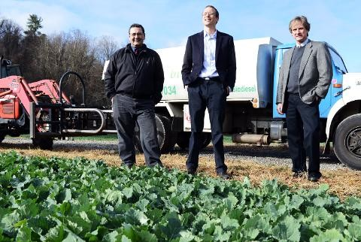
Biomass
Field to Fryer to Fuel: 50 acres of canola fields were planted on the Biltmore Estate in partnership with Blue Ridge Biofuels in a Field to Fryer to Fuel program. 12-11-12 – Erin Brethauer (ebrethau@citizen-times.com)
Biltmore Growing Crops for Food and Fuel

Dec 11, 2012 Written by Dale Neal
ASHEVILLE -- Rather than importing cooking oil from Canada or fuel oil from the Mideast, what if you could grow what you eat, and ultimately, use to power your vehicle?
The Biltmore Estate, Blue Ridge Biofuels and other partners are taking up that challenge under the
Field to Fryer to Fuel program. Backed by a $130,000 grant from the Biofuels Center of North Carolina and $64,000 in federal economic development funds, the partners hope to grow a sustainable food and energy supply with a new cash crop for mountain farmers and more jobs in alternative energy.

1. Before reading further, explain what you think they mean by “field to fryer to fuel”?
__________________________________________________________________________________

“We’re trying to build out a business model that will be economically viable for farmers, for local restaurants and for Blue Ridge Biofuels,” explained Ron Townley, working with the Advantage West Economic Development Group to shepherd the project. Planted back in September, the fields alongside the French Broad River are now green and ankle-high with the canola crop, which looks a lot like kale or mustard greens. Biltmore workers planted about 60 acres of the winter crop. After the plants grow about waist-high, they will be harvested next spring. The pressed plants themselves can be reused as a valuable feed stock to be fed to the estate’s livestock herds.
- What is an added benefit from growing canola for oil?
__________________________________________________________________________________

Blue Ridge Biofuels will take the crop’s real payoff — the canola seed — and press that into a food grade cooking oil which can be used by chefs frying up dishes in the kitchens of Biltmore restaurants. The used cooking oil will then be recycled by Blue Ridge Biofuels into homegrown biodiesel, a fuel that can then be used in the estate’s farm tractors and other vehicles. The crops should produce about 7,000 gallons of cooking oil. Blue Ridge Biofuels should be able to collect and process about 5,300 gallons of biodiesel. Ted Katsigianis, Biltmore’s vice president of agricultural sciences, said the estate is experimenting with four varieties, using different soil types on the estate. The estate uses seeds that were not genetically modified.

- They generate 7,000 gallons of oil for cooking, once the restaurants have used the oils to fry the French fries, etc. why would there only be 5,300 gallons for vehicle use?
__________________________________________________________________________________

The project is just the latest effort toward greater sustainability at Biltmore. The estate has installed an array of 5,000 solar panels to generate electricity. Biltmore also uses biodiesel in many of its vehicles, and has converted visitor’s shuttle buses to run on propane. “It’s been a longtime family interest and part of our mission to be a community leader in environmental issues. We would like to become sustainable with our food and energy,” said Chuck Pickering, Biltmore’s executive vice president.
- Name two other ways (besides the biofuel project) the Biltmore Estate is trying to become self-sustaining:
__________________________________________________________________________________
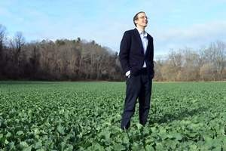
For Blue Ridge Biofuels, securing more vegetable oil as the basic ingredient for its production makes good business sense, said Blue Ridge general manager Woody Eaton. “I would like to see other farmers plant oil-producing crops that Blue Ridge could then turn into biodiesel.” Soybeans yield about 45 gallons of oil per acre, and canola can produce up to 100 gallons per acre, which could prove an attractive winter cash crop for area farmers.
Woody Eaton, general manager of Blue Ridge Biofuels, stands in a canola field on the Biltmore property. The fields are part of the Field to Fryer to Fuel program, a partnership between the estate, chefs and biofuels. / Erin Brethauer ebrethau@citizen-times.com
The program could help the state as a whole achieve its goal of locally producing 10 percent of its fuel supply by 2017, Townley said. “This pilot program is about closing the loops of our supply chain.”

5. What are two crops that could be used to generate biofuels?
____________________________________________

6. What is so great about WHEN you grow the typical biofuel crops?
__________________________________________________________________________________

7. And now for your opinion, what could Cane Creek do to join the self-sufficient movement?
__________________________________________________________________________________
__________________________________________________________________________________
__________________________________________________________________________________
__________________________________________________________________________________

8. Further explain what is meant by “field to fryer to fuel”?
__________________________________________________________________________________
__________________________________________________________________________________
__________________________________________________________________________________
__________________________________________________________________________________

Biomass - Fermentation in a Bag

Overview
This classroom activity is a basic experiment that allows for the observation the fermentation process and the challenge of producing ethanol from cellulosic sources. Students combine yeast and warm water with different feedstock in a “snack” size reseal-able zipper bag and observe as the yeast “eats” the feedstock (Options are to use sugar, corn starch, corn meal, sawdust, finely ground grass clippings, dead leaves, composting materials, etc.) and produces carbon dioxide and ethanol. Students can create multiple set-ups to compare how yeast reacts with different feedstocks.

Fermentation in a bag – Recommended Recipe:
In a snack-size resealable zipper bag, combine feedstock:
4 grams of sugar & 4 grams of yeast
4 grams of corn meal & 4 grams of yeast
4 grams of your choice of feedstock & 4 grams of yeast
Add 50mL of warm tap water to each setup and zip the bags closed - removing as much air as possible.
Mix gently. Lay bag on a flat surface and watch for results – fastest results should be achieved in 15 minutes.
Warning: As the yeast produce carbon dioxide, the bag will expand – it may even pop! Be sure to monitor the bag and release the gas if becomes too inflated.

Basic Experiment
Using table sugar (sucrose) as a feedstock will yield the most rapid results. Some alternate feedstocks include corn meal (students could even grind their own corn), corn stover powder, sawdust, finely ground grass clippings, dead leaves, composting materials, etc. Feedstocks with a starchy or fibrous composition will not ferment as well.
Feedstock | Ethanol Readings | 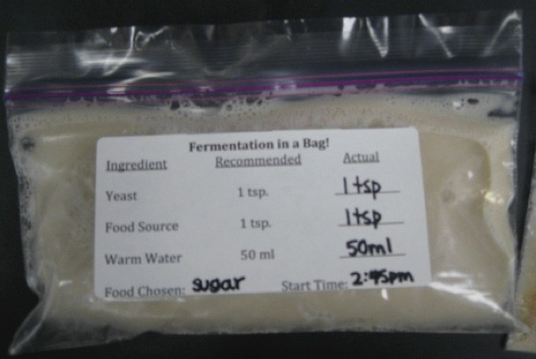
Sugar
Corn Meal
Choice:________________________
Questions to answer about the bags:
- If the bag is inflating, what is filling it up?

- Are you observing fermentation? How do you know?

- How did the yeast respond to different kinds of “food”? Why do you think there is a difference?

- What feedstock proved to be the “favorite” for the yeast?

- Why might we want to use cellulosic plant materials instead of sugar for making ethanol?

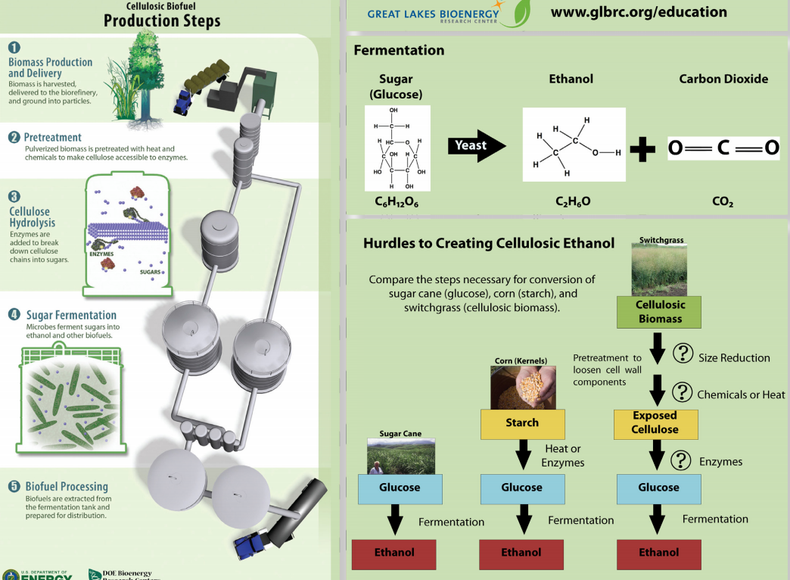

- List the five steps for making Biofuels

- What three additions must be made to get some feedstock to generate Ethanol?

- What gas is a by-product of the biofuel process? Discuss why this may be a problem.

