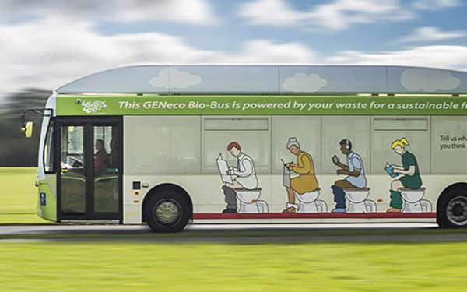
Commuter bus runs on human waste
By Corinne Iozzio Smithsonian.com
January 16, 2015
On November 20, 2014, tourists boarded a bus at Bristol Airport. It ran to Bath in England. The markings on the bus, however, showed that this bus was different. One side of the bus pictured people dumping food scraps into food-recycling bins. This is how people dispose of waste in the United Kingdom. The other side showed people sitting on toilets.
The vehicle was the Bio-Bus. It's the first bus in the U.K. using fuel made from sewage and food waste. The biogas plant GENeco built the bus. Each year, five people make enough sewage and food waste to run the bus for about 186 miles. The bus offers sustainable, low-pollution transportation. Gas powered vehicles have an important role to play in improving air quality in U.K. cities, but the Bio-Bus goes further than that and is actually powered by people living in the local area, including quite possibly those on the bus itself, GENeco general manager Mohammed Saddiq said. Using bio [gas] in this way not only provides a sustainable fuel, but also reduces our reliance on traditional fossil fuels. The source of the fuel may be yucky. But the bus is a breath of fresh air. A Fast Company report claims that replacing diesel fuel cuts pollutants by 97 percent. GENeco also claims the bus releases 20 to 30 percent less carbon dioxide than a diesel model would. So it contributes less to climate change.
The GENeco biogas plant makes enough electricity to power 8,500 homes. Biogas is created in a tank without oxygen, called a digester. Microorganisms break down organic material. The process creates biogas and byproducts with fiber. The byproducts are made into animal bedding, fertilizers and other things. Then biogas is concentrated to the levels needed to replace fuel or make electricity. This process uses different waste sources. For example, it can make biogas from landfills, wastewater, manure, and farm waste. The GENeco plant converts more than 2.6 billion cubic feet of sewage. It also converts more than of 38,000 tons of food waste. Biogas would make a big difference if used worldwide.
The EPAs National Renewable Energy Laboratory estimates that gathering all available U.S. sources of biogas could reduce the natural gas used for electricity by 46 percent. It could completely replace natural gas in transportation. In fact, tapping all sources could produce enough biogas to replace 35 billion gallons of gasoline. Currently, more than1,500 U.S. wastewater treatment centers use biogas digesters. Some produce all the electricity the center needs to operate. Using biogas for transportation is still new. Renewable-energy laws, however, have spurred similar projects across Europe recently. For example, Sweden uses biogas to run a fleet of more than 36,000 trucks, buses, and other vehicles. And about 80 poo-powered buses operate in Oslo, Norway.
In 2010, GENeco introduced the Bio-Bug before trying to transform public transit. The Bio-Bug showed that transportation vehicles could use fuels from sewage. The Bath Bus Company operates the Bio-Bus. It also runs tour buses in U.K. destinations. But it hasn't committed to using more Bio-Buses.

Article Reading Name ________________________________________ Blk ___ Date _____________ NB#____

Article(s) summary: Please give a brief statement in your own words explaining the articles intent. | Vocabulary- find two words on the reverse side that you do not know or are crucial to the article. Write the words below and provide a definition. HIGHLIGHT the WORD in the ARTICLE!!!
Article 1 | Word: | Definition:
Article 2 | Word: | Definition:
What is the main idea being discussed in this Article 1? | What is the main idea being discussed in this Article 2?
Give at least one bullet point as support: | Give at least one bullet point as support:
Below list one statistical piece of information provided in the article: | Below list one statistical piece of information provided in the article:
Rank the article’s quality for providing you information clearly:  Poor 1 2 3 4 5 Excellent | Rank the article’s quality for providing you information clearly:  Poor 1 2 3 4 5 Excellent

Commuter Bus Runs on Human Waste
Article Quiz

- How do you think U.S. consumers would react to public transportation fueled by human waste?

- Would you support bio-buses to run throughout your own community and throughout the US? Why or why not.

- The bio-bus runs off of ________________________ and_____________________. This creates ____________. By using this alternative fuel, the bio-bus uses ______ to _____ percent less carbon dioxide than a diesel model would.

- Although ironic, how is the biofuel bus a “breath of fresh air”? (Meaning why is this source of energy a healthier alternative from using fossil fuels?)

